Generative AI

# Generative AI Architectures and Models

**1. Introduction**

* Overview of generative AI architectures used in text, speech, and image generation.
* Importance of choosing the right model for specific tasks, like personalized video generation.

**2. Common Generative AI Architectures & Models**

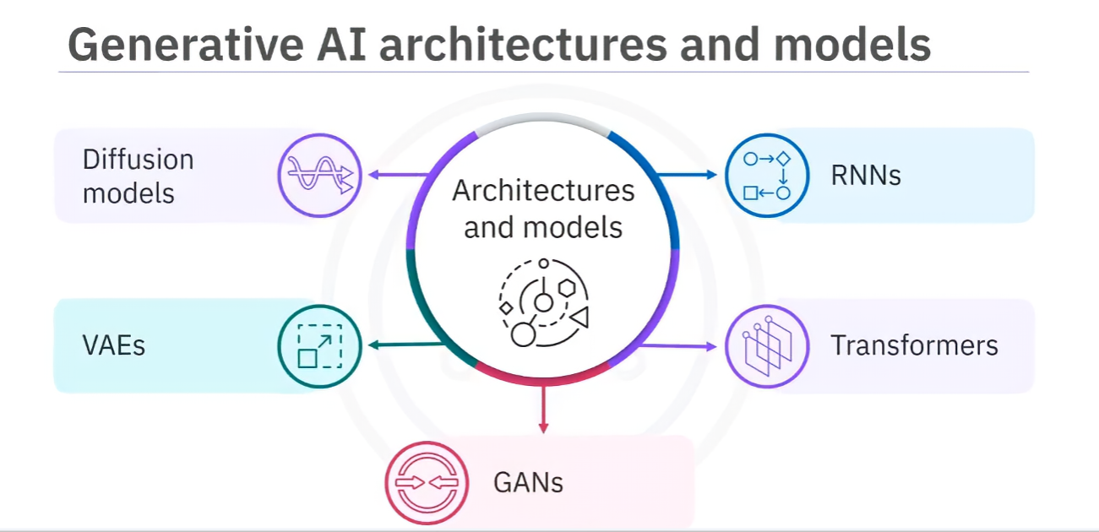

* **Recurrent Neural Networks (RNNs)**

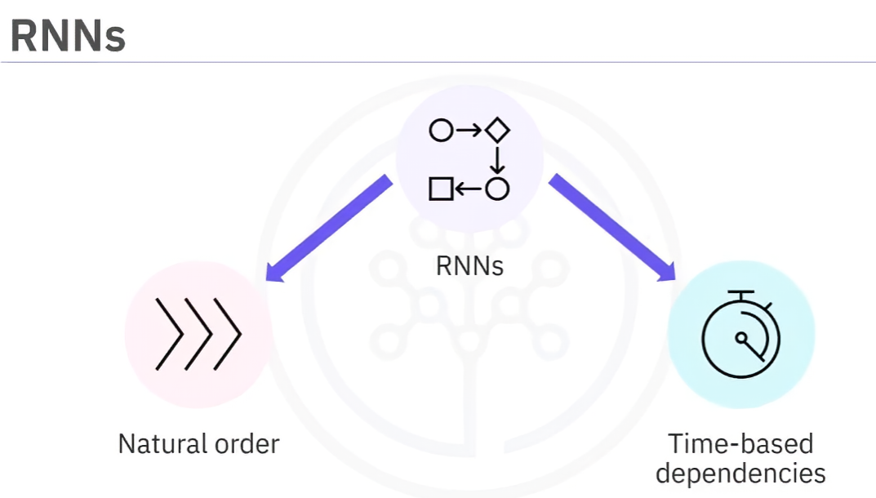

* + Used for sequential or time-series data (e.g., language modeling, speech recognition).
  + Loop-based design enables memory of previous inputs for context.

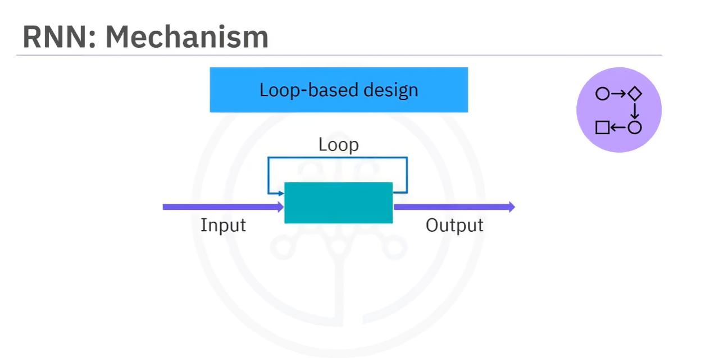

* + Fine-tuning involves adjusting weights for specific tasks.

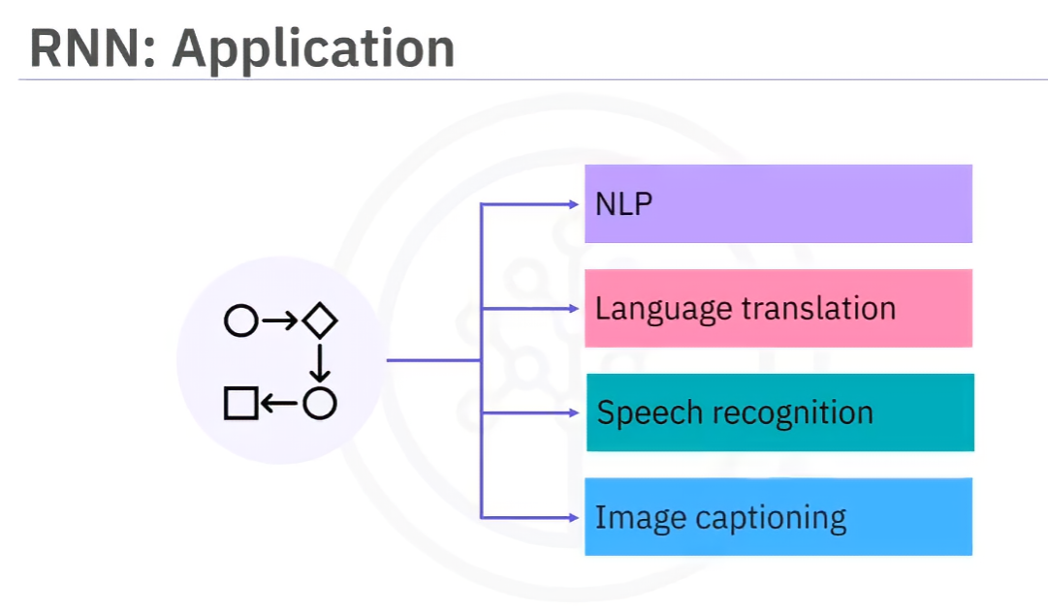

* **Transformers**

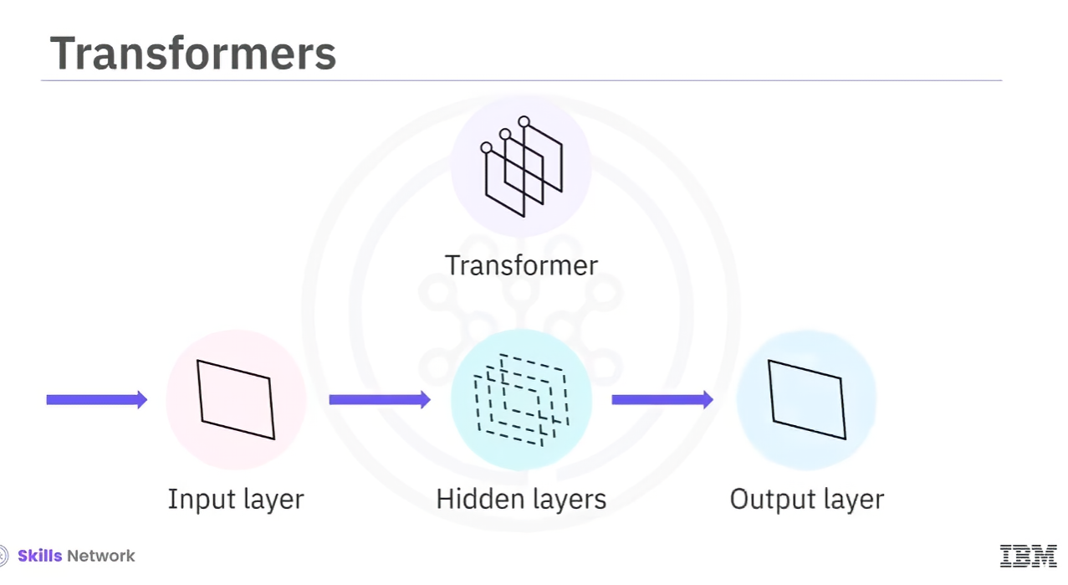

* + Deep learning models with a **self-attention mechanism** for focusing on key input segments.
  + Information flows through multiple layers, allowing efficient parallel training.
  + 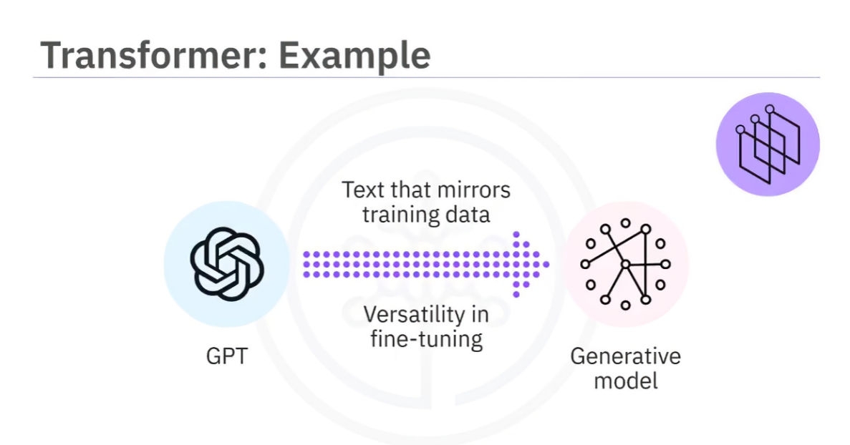**Fine-tuning** typically involves adjusting only output layers while keeping core layers fixed.
  + Example: **GPT (Generative Pretrained Transformer)** – excels at text generation.
* 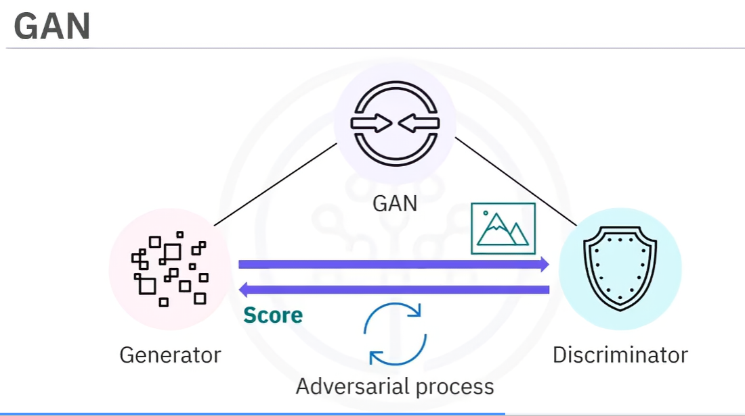**Generative Adversarial Networks (GANs)**
  + Consist of two components:
    - **Generator** – creates synthetic data.
    - **Discriminator** – evaluates authenticity by comparing with real data.
  + Used in **image & video generation** through an adversarial process.
* **Variational Autoencoders (VAEs)**

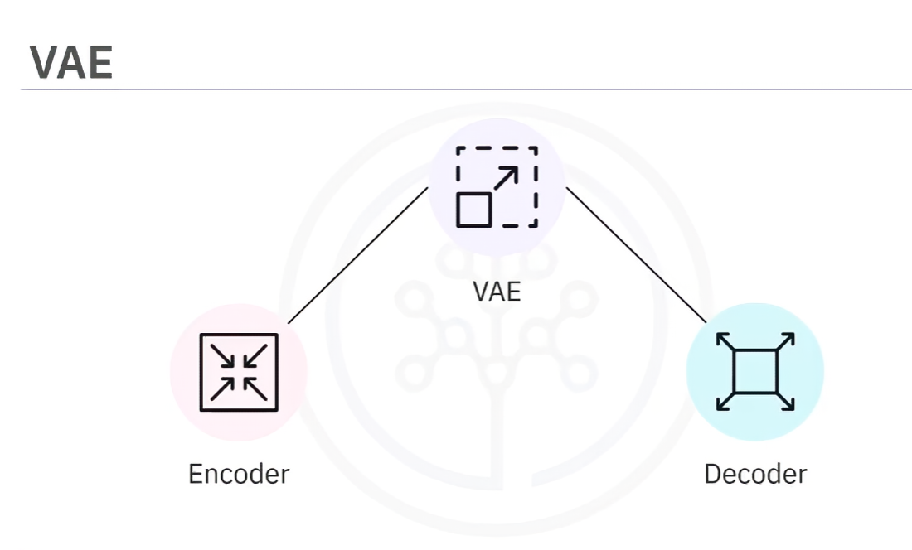

* + Operate on an **encoder-decoder framework** to learn latent data representations.
  + Represent data as probability distributions, capturing patterns for generating new samples.

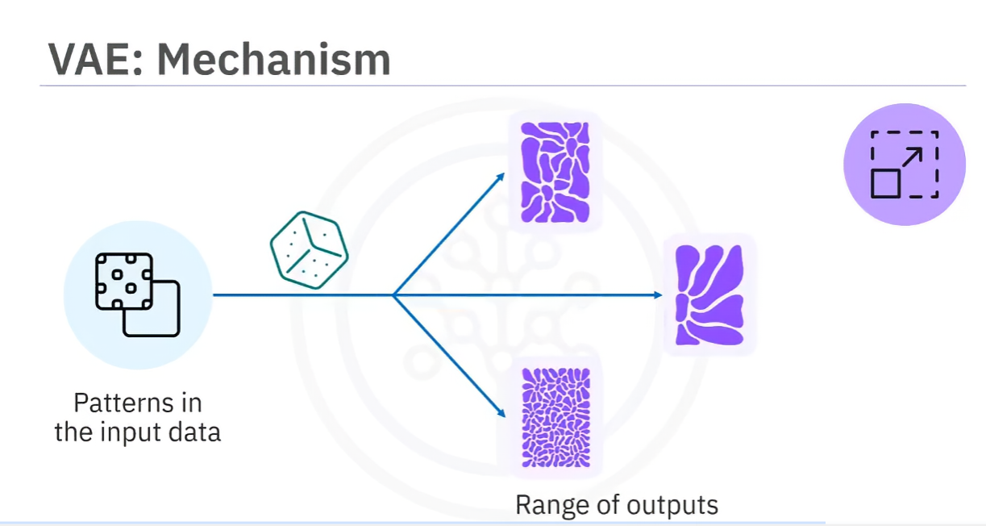

* + Applied in **art, creative design, and feature extraction**.
* **Diffusion Models**

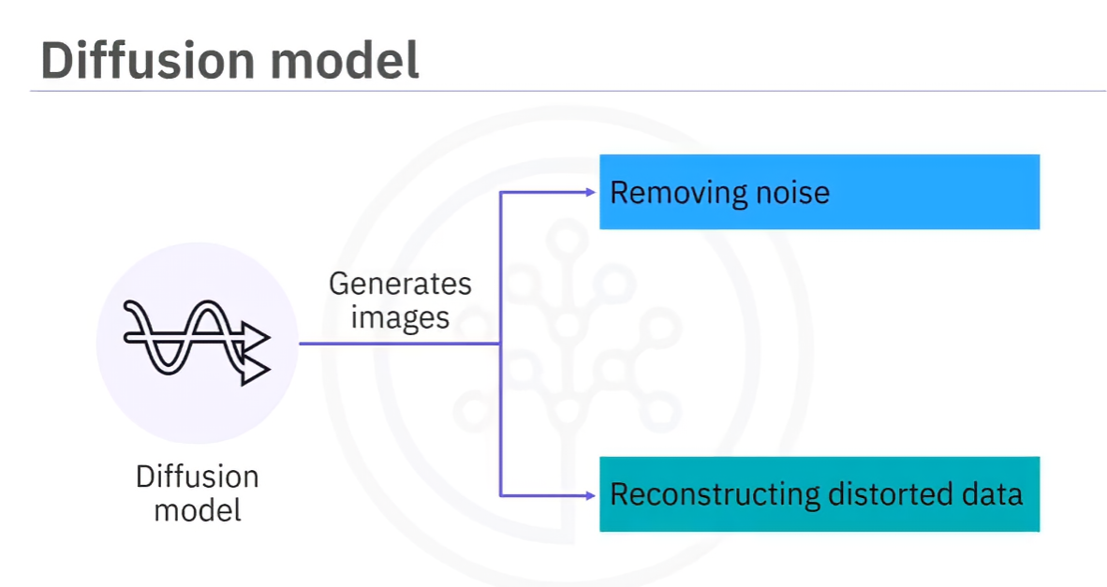

* + Probabilistic generative models trained to **remove noise** from data.
  + Used for **image generation and restoration** (e.g., restoring old or distorted images).

**3. Differences in Training Approaches**

* **RNNs**: Loop-based memory structure for sequential data.
* **Transformers**: Self-attention mechanism for efficient parallel training.
* **GANs**: Competitive learning process between generator and discriminator.
* **VAEs**: Encoder-decoder architecture capturing latent distributions.
* **Diffusion Models**: Statistical approach for noise removal and reconstruction.

**4. Relationship Between Generative AI & Reinforcement Learning (RL)**

* Traditional **RL**: AI agents interact with environments to maximize rewards.
* Generative AI models **use RL techniques** for optimization and fine-tuning (e.g., RLHF in ChatGPT).

**5. Recap**

* **RNNs, transformers, GANs, VAEs, and diffusion models** are key architectures in generative AI.
* **Each model has unique strengths**:
  + **RNNs**: Sequential processing.
  + **Transformers**: Self-attention for text/speech tasks.
  + **GANs**: Adversarial training for realistic image/video synthesis.
  + **VAEs**: Probabilistic approach for new sample generation.
  + **Diffusion models**: Noise removal for high-quality image generation.
* **Reinforcement learning is used to enhance generative AI model performance.**

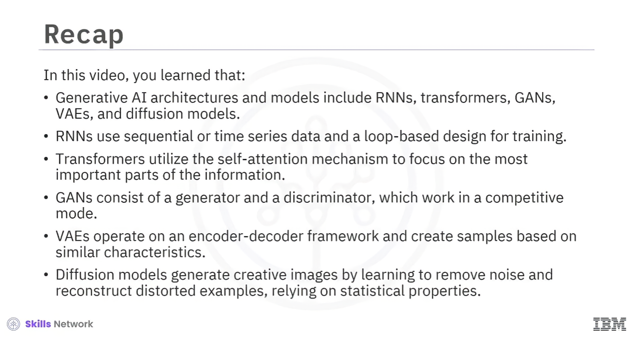

## Generative AI for NLP

**1. Introduction**

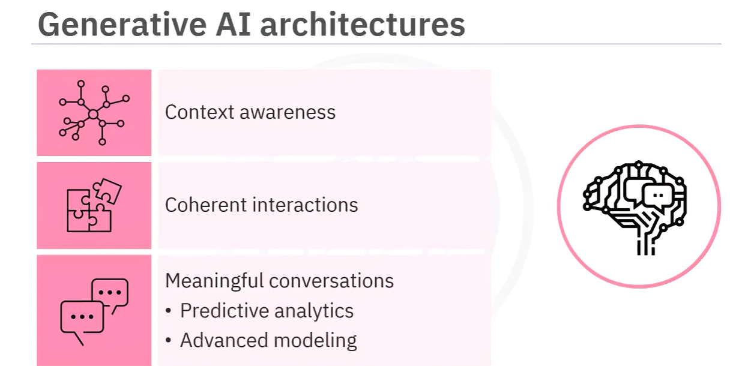

* Generative AI enables machines to understand and generate human-like language.
* Helps develop applications like chatbots and virtual assistants.
* Enhances language processing through context awareness and predictive analytics.

**2. Evolution of Generative AI for NLP**

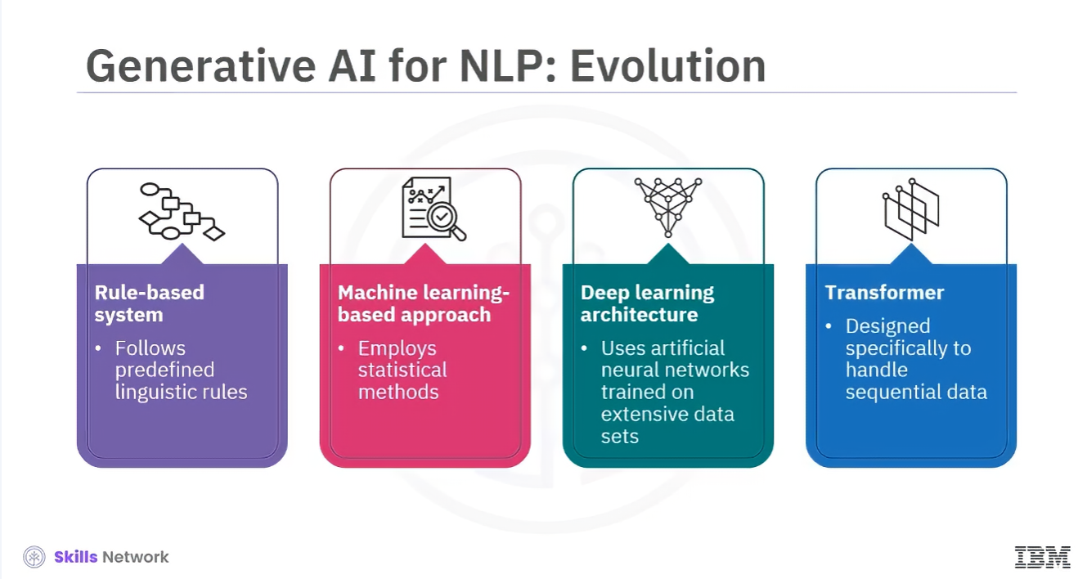

* **Rule-based systems**: Follow predefined linguistic rules but lack flexibility.
* **Machine learning approaches**: Use statistical methods to learn from large datasets.
* **Deep learning**: Trains artificial neural networks for better language interpretation.
* **Transformers**: Latest advancement, excelling in context understanding and dependencies.

**3. Applications of Generative AI in NLP**

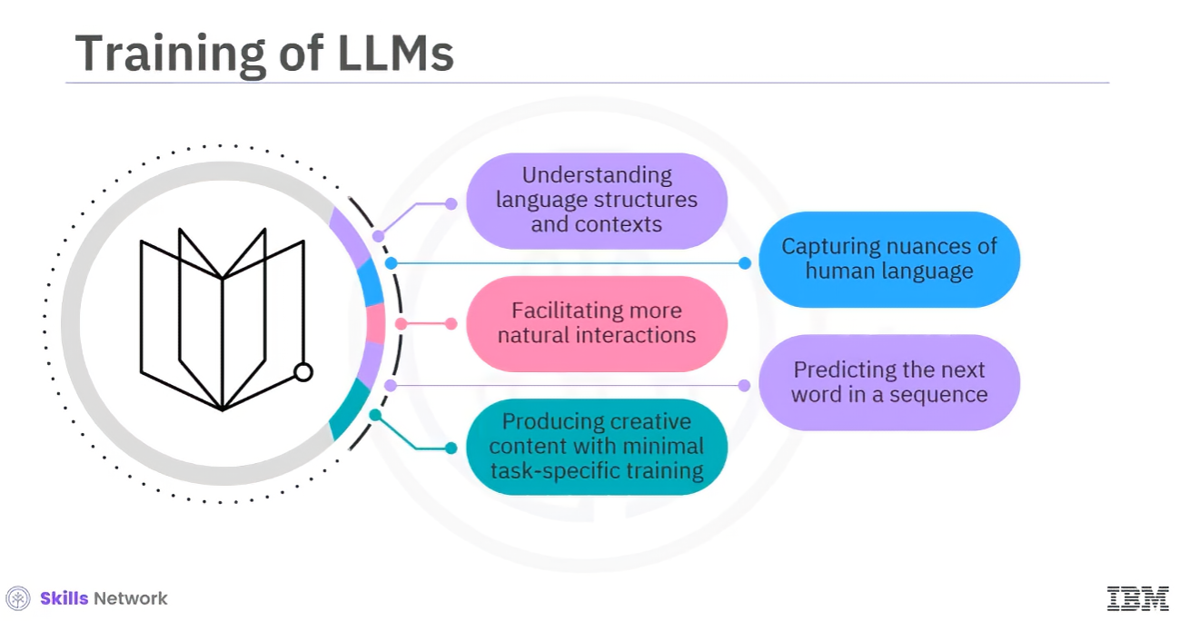

* **Machine translation**: Improves accuracy and context awareness.
* **Chatbots & virtual assistants**: Enhances conversation naturalness and personalization.
* **Sentiment analysis**: Captures subtle language expressions for deeper insights.
* **Text summarization**: Extracts key information for precise summaries.

**4. Large Language Models (LLMs)**

* **Foundation models trained on massive datasets (petabytes of data).**
* **Contain billions of parameters optimized for specific tasks.**
* **Capable of text generation, translation, and content creation.**
* **Examples:**
  + **GPT**: Text generation (chatbots, content creation).
  + **BERT**: Understanding word context (sentiment analysis, Q&A).
  + **BART & T5**: Encoder-decoder models for multiple NLP tasks.

**5. GPT vs. ChatGPT**

* **GPT**: General text generation, trained mainly using supervised learning.
* **ChatGPT**: Focuses on conversations, fine-tuned using Reinforcement Learning from Human Feedback (RLHF).

**6. Importance & Challenges**

* LLMs contribute to **natural language understanding and generation advancements**.
* Models can be **fine-tuned for specific industries** (e.g., retail product categorization).
* Risks: **Potential misinformation, biases, and societal impact**.

**7. Recap**

* **Generative AI has evolved from rule-based systems to transformers.**
* **LLMs like GPT, BERT, BART, and T5 play key roles in NLP advancements.**
* **Applications include machine translation, chatbots, sentiment analysis, and summarization.**
* **Fine-tuning allows customization but requires careful handling of biases and accuracy.**

## Basics of AI Hallucinations

**2. Introduction**

1. Large language models (LLMs) generate authoritative text but may produce inaccurate or biased content.
2. These inaccuracies can result from AI hallucinations.

**3. AI Hallucinations**

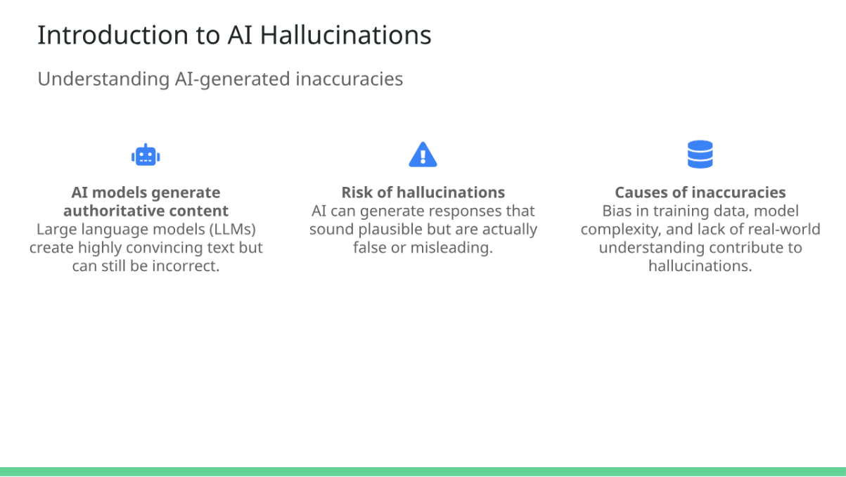

1. Occurs when an AI model generates output that appears accurate but is unrealistic, inaccurate, irrelevant, or nonsensical.
2. Similar to human hallucinations.
3. Example:
   * ChatGPT falsely claimed an Australian mayor was guilty of bribery, though he had actually reported the issue.
4. Causes:
   * Biases in training data.
   * Limited training.
   * Model complexity.
   * Lack of human oversight.
   * Outputs not based on learned patterns.
5. **Problems Caused by AI Hallucinations**

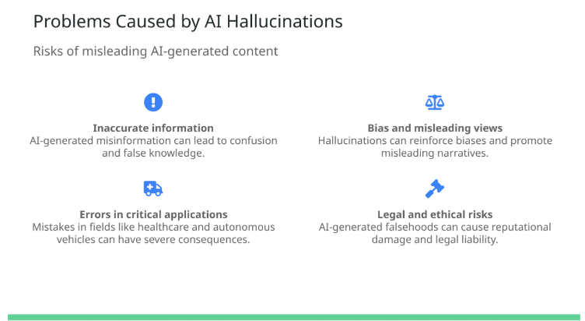

1. **Inaccurate information generation.**
2. **Creation of biased or misleading views.**
3. **Incorrect input in sensitive applications** (e.g., autonomous vehicles, medical diagnosis).
4. **Potential legal or ethical consequences** (e.g., misrepresentation in legal documents).

**5. Methods for Mitigating AI Hallucinations**

1. Train models on high-quality, unbiased data.
2. Avoid manipulation of input data.
3. Continuously evaluate and improve models.
4. Fine-tune pre-trained LLMs using domain-specific data.

**6. Preventing Problems from AI Hallucinations**

1. **Acknowledge limitations:** AI models predict words based on patterns, not actual understanding.
2. **Ensure human oversight:** Regular fact-checking and testing.
3. **Provide additional context:** Better input improves response accuracy.

**7. Summary**

1. **AI hallucinations** occur when AI-generated output appears correct but is inaccurate or nonsensical.
2. **Problems include:**
   * Inaccurate information.
   * Biased views.
   * Incorrect input for critical applications.
3. **Prevention methods:**
   * Extensive high-quality training.
   * Avoiding input manipulation.
   * Continuous model improvement.
   * Domain-specific fine-tuning.
   * Human oversight.
   * Providing context in prompts.

# Overview of Libraries and Tools in Generative AI for NLP

**Objective**  
After reading this, you will be able to describe key features and the significance of libraries and tools used in generative AI for NLP.

**Introduction**

* Generative AI applications for NLP require a deep understanding of linguistic nuances.
* Various libraries and tools make these applications more accessible and efficient.
* Key libraries and tools include PyTorch, TensorFlow, Hugging Face, LangChain, and Pydantic.

**PyTorch**

* Open-source deep learning framework developed by Facebook (Meta).
* Features dynamic computation graphs (Autograd) for flexibility.
* Rich ecosystem with tools like **torchtext** for NLP.
* Used in research and development for neural network models in NLP.

**TensorFlow**

* Open-source machine learning and deep learning framework developed by Google.
* Scalable architecture for transitioning from research to production.
* **TensorFlow Extended (TFX)** supports production-ready ML pipelines.
* **Keras integration** provides a user-friendly API for deep learning.
* Used for NLP tasks such as sentiment analysis and text classification.

**Hugging Face**

* Platform with an open-source library offering pretrained models.
* **Extensive Model Hub** with models for translation, question-answering, etc.
* **Transformers Library** simplifies usage of pretrained models for NLP.
* **Datasets Library** provides large-scale datasets for evaluation.
* **Tokenizers Library** optimizes tokenization for NLP models.
* Used for NLP applications such as named entity recognition and text summarization.

**LangChain**

* Open-source framework for developing AI applications with LLMs.
* **Advanced prompt engineering** tools for refining model responses.
* **Seamless integration** with popular models like GPT.
* Used for building chatbots and analytical tools.

**Pydantic**

* Python library for data validation and parsing.
* Ensures **data integrity** through robust validation.
* Supports **efficient settings management** for scalable applications.
* Used in NLP pipelines to validate and manage large datasets.

**Summary**

* Various libraries and tools help develop NLP applications using generative AI.
* **PyTorch**: Flexible deep learning framework with dynamic computation graphs.
* **TensorFlow**: Scalable framework with Keras integration for deep learning.
* **Hugging Face**: Platform offering pretrained models and NLP tools like Transformers.
* **LangChain**: Framework for building AI applications using LLMs with prompt engineering.
* **Pydantic**: Ensures data validation and integrity in NLP applications.

# Preparing Data

## Tokenization Process for AI Models

1. **Introduction to Tokenization**:
   * Tokenization breaks down text into smaller pieces, called tokens, to help AI models understand the text.
   * Example: Sentence "IBM taught me tokenization" becomes tokens: **IBM**, **taught**, **me**, **tokenization**.

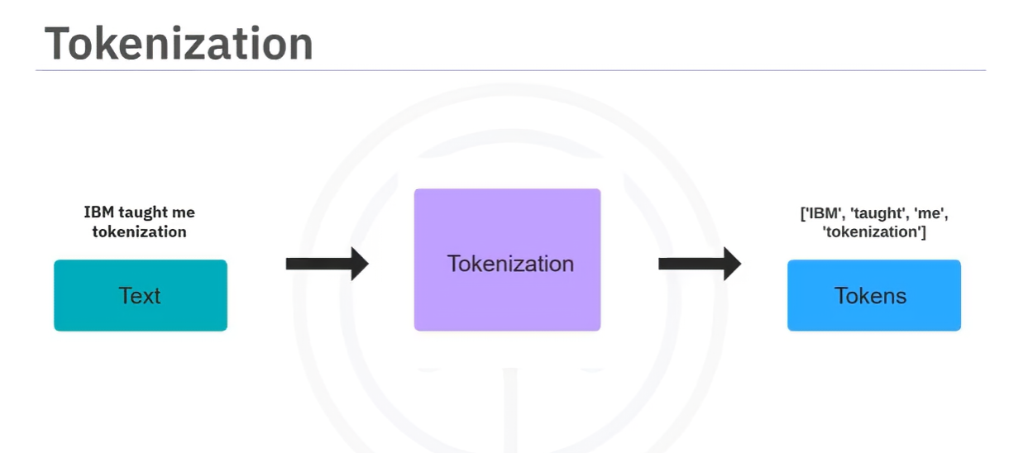

1. **Types of Tokenization**:

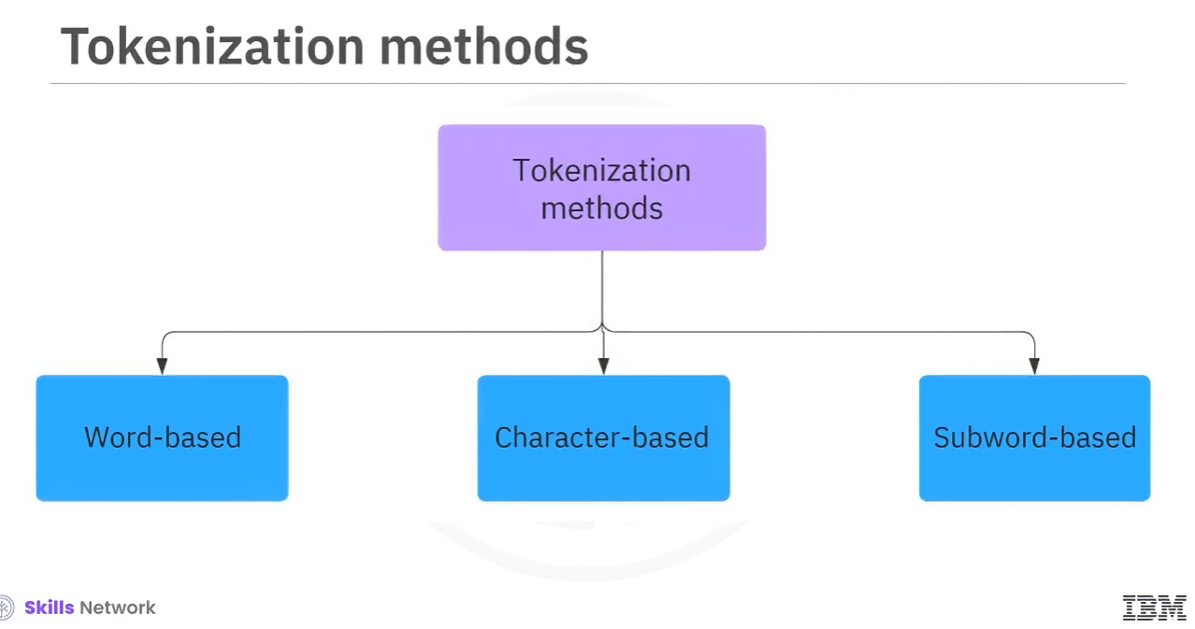

* + **Word-based Tokenization**:

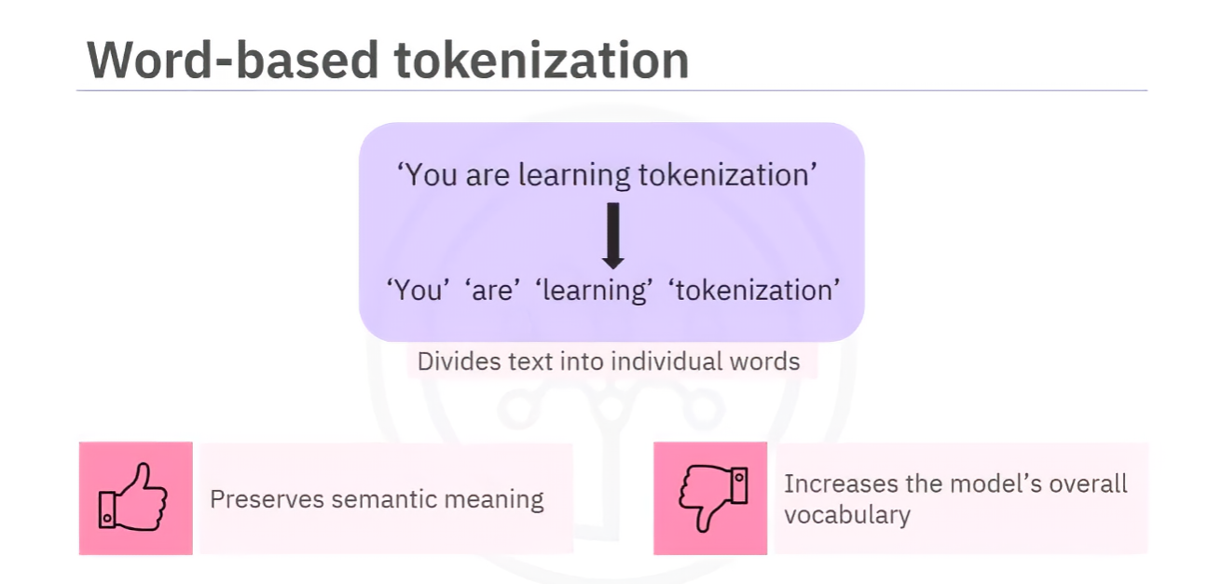

* + - Splits text into individual words, each considered a token.
    - **Advantages**: Preserves semantic meaning.
    - **Disadvantages**: Increases model vocabulary size, can lead to issues with variations of words (e.g., "unicorn" vs. "unicorns").
  + **Character-based Tokenization**:
    - * 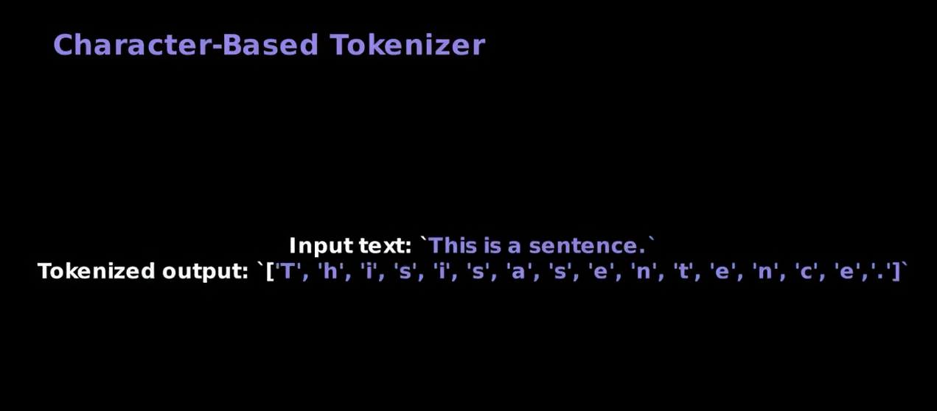
    - Splits text into individual characters.
    - **Advantages**: Small vocabulary size.
    - **Disadvantages**: Characters may not convey the same meaning as words, increases computational load.
  + **Subword-based Tokenization**:

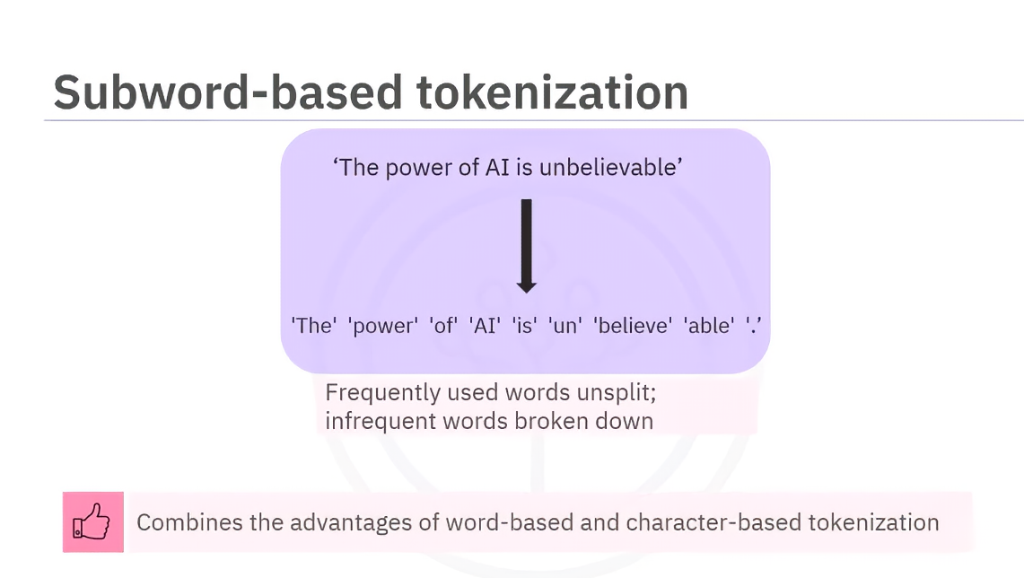

* + - Combines word-based and character-based methods.
    - Frequently used words remain unsplit, while rare words are split into meaningful sub-words.
    - **Advantages**: Efficient for handling infrequent words and preserving semantic meaning.
    - Examples of algorithms:

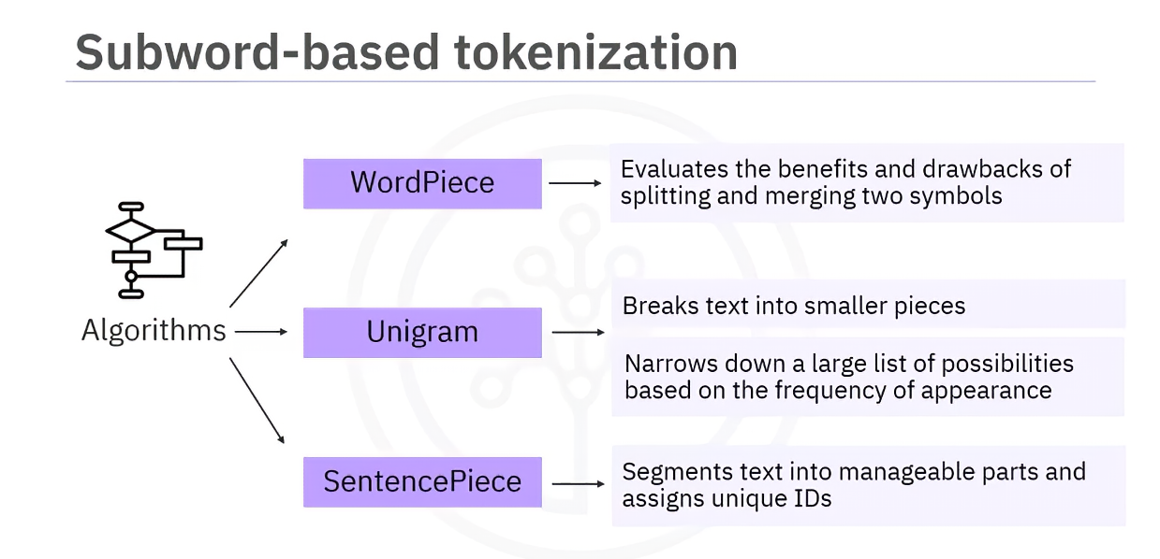

* + - * **WordPiece**: Merges and splits symbols based on value.
      * **Unigram**: Narrows down token possibilities iteratively.
      * **SentencePiece**: Segments text into manageable pieces and assigns unique IDs.

1. **Tokenizers**:
   * Tools like **NLTK** and **spaCy** tokenize text.
   * These tokenizers handle word-based tokenization but may split similar words differently.
2. **PyTorch Implementation**:
   * Use **torchtext** to tokenize sentences into words or sub-words.
   * build_vocab_from_iterator function creates a vocabulary and maps tokens to indices.
   * Example code:
     + Tokenize sentences and convert tokens to indices.
     + Special token **UNK** used for unknown words.
     + Vocabulary (vocab.get_stoi) provides a dictionary mapping tokens to indices.
3. **Adding Special Tokens**:
   * Special tokens like **BOS** (beginning of sentence) and **EOS** (end of sentence) can be added.
   * Tokenized sentences may be padded with **pad tokens** to ensure uniform sentence length.
4. **Key Takeaways**:
   * Tokenization is essential for breaking text into meaningful parts for AI models.
   * Different tokenization methods serve different purposes and have unique trade-offs.
   * Special tokens and padding ensure consistent input formatting for machine learning models.

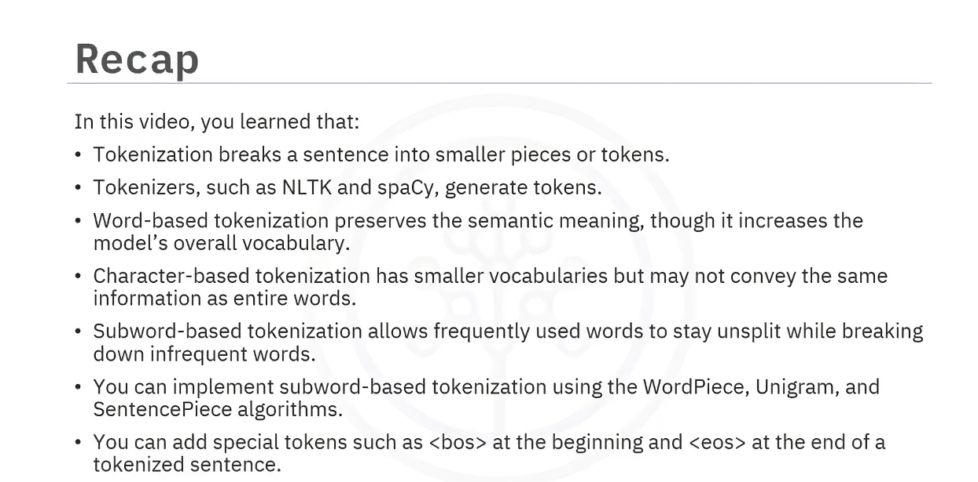

## Data Loaders in PyTorch

1. **Introduction to Data Loaders**

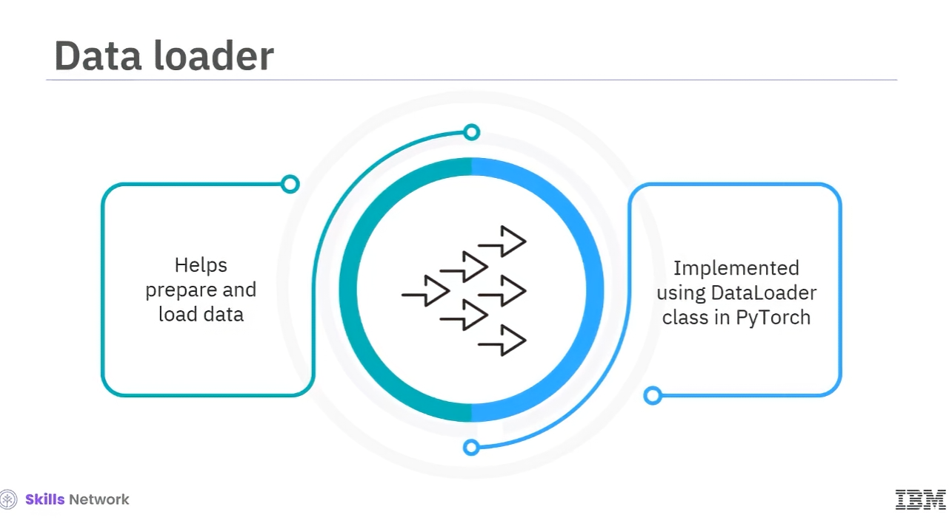

* + Data loaders help efficiently load and preprocess large datasets for AI model training.
  + They enable **batching, shuffling, and on-the-fly transformations** for optimal training.

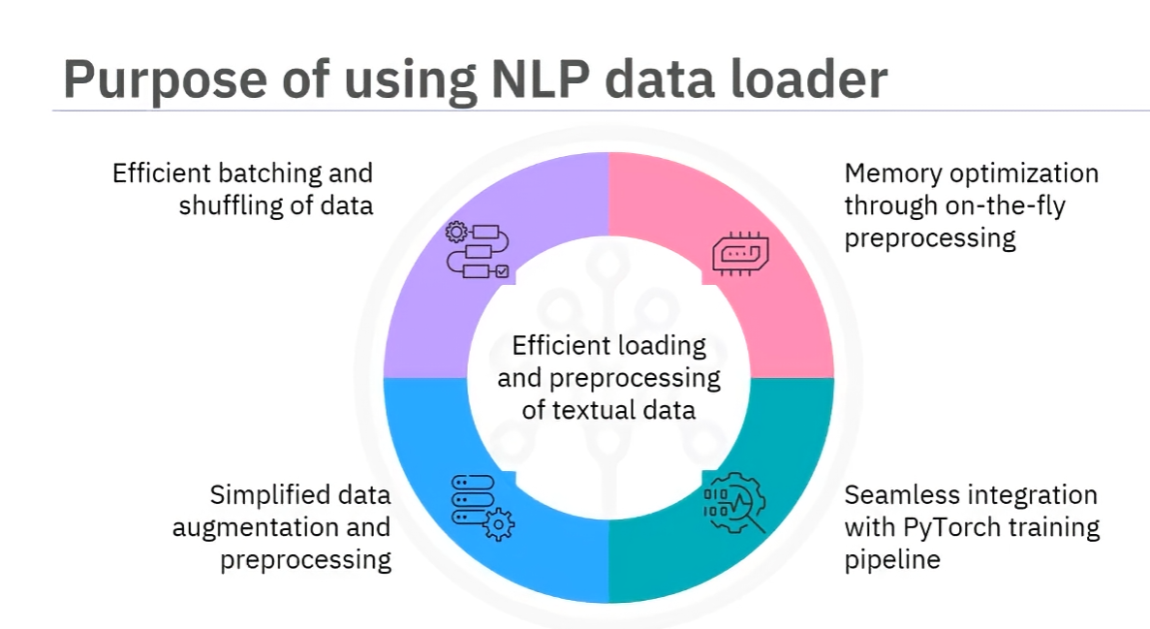

* + PyTorch provides a **DataLoader** class to handle these operations seamlessly.

1. **Dataset Handling in PyTorch**
   * A **dataset** consists of samples and their labels, split into **training, validation, and test sets**.

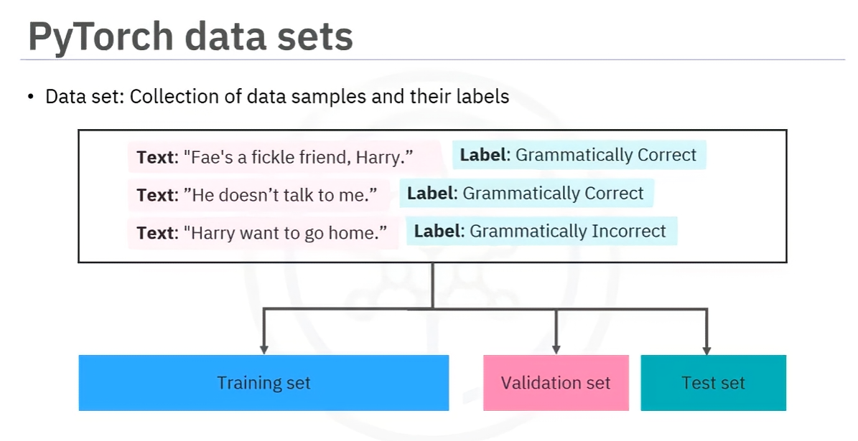

* + Custom datasets can be created by inheriting from torch.utils.data.Dataset.

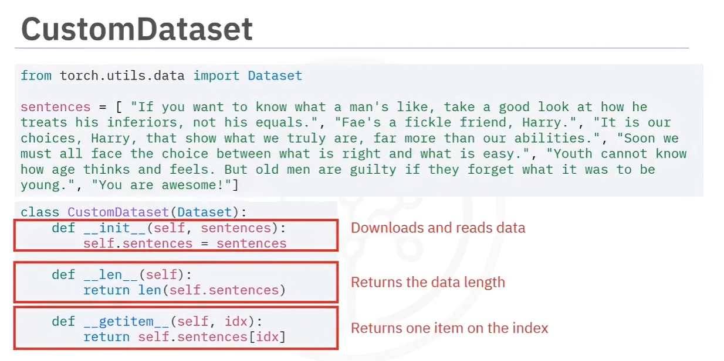

* + Key methods in a custom dataset:
    - __init__(): Initializes the dataset.
    - __len__(): Returns the number of samples.
    - __getitem__(): Retrieves a specific sample.

1. **Iterators and Data Loading**

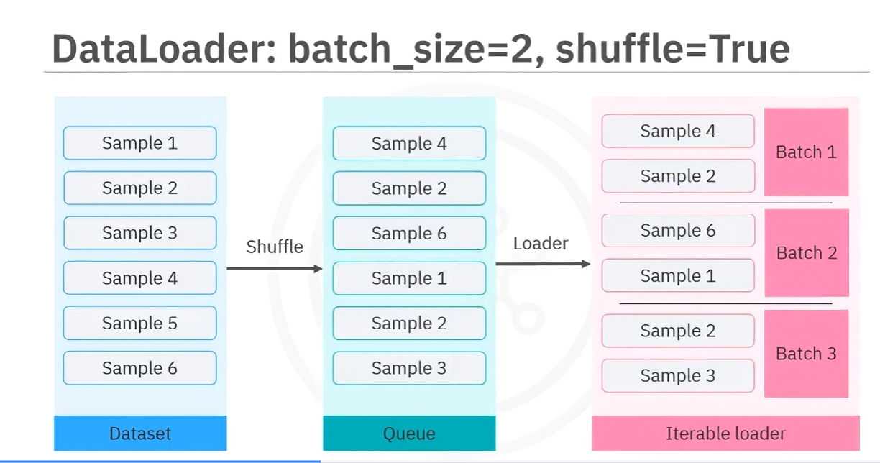

* + Data loaders are **iterators** that facilitate looping over datasets.

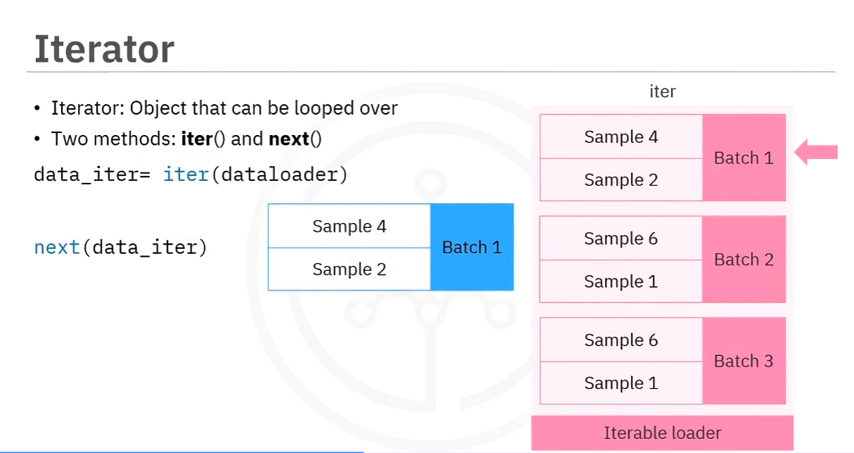

* + The **batch size** determines how many samples are loaded per iteration.
  + **Shuffling** prevents models from memorizing data order and improves generalization.

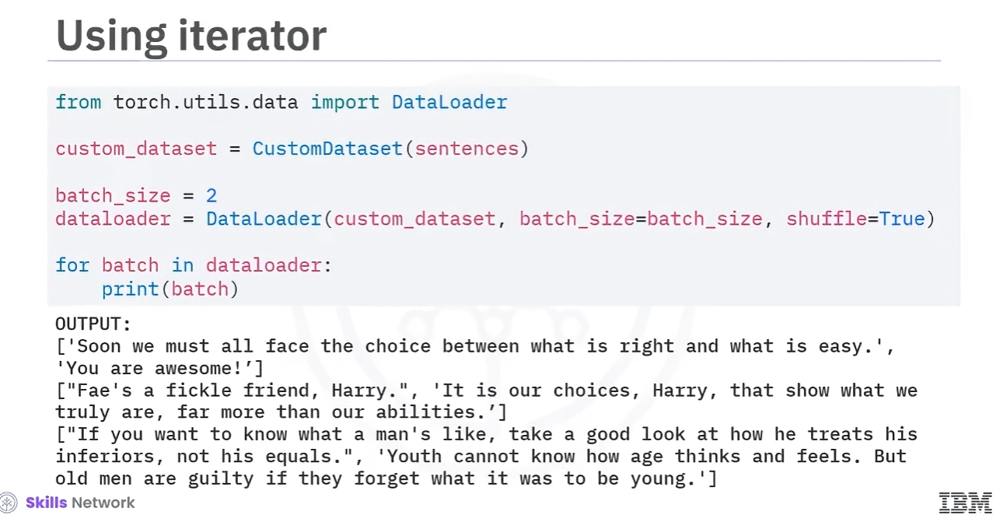

1. **Batch Processing & Transformations**

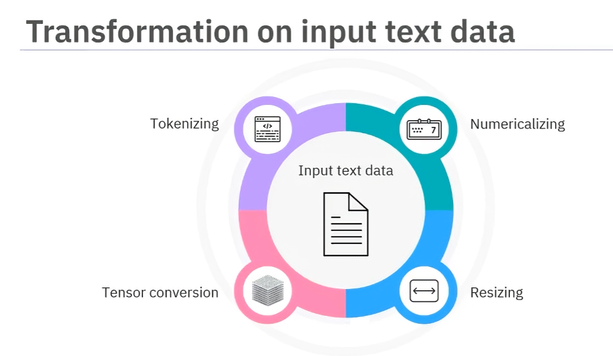

* + **Tokenization**: Converts text into tokens.

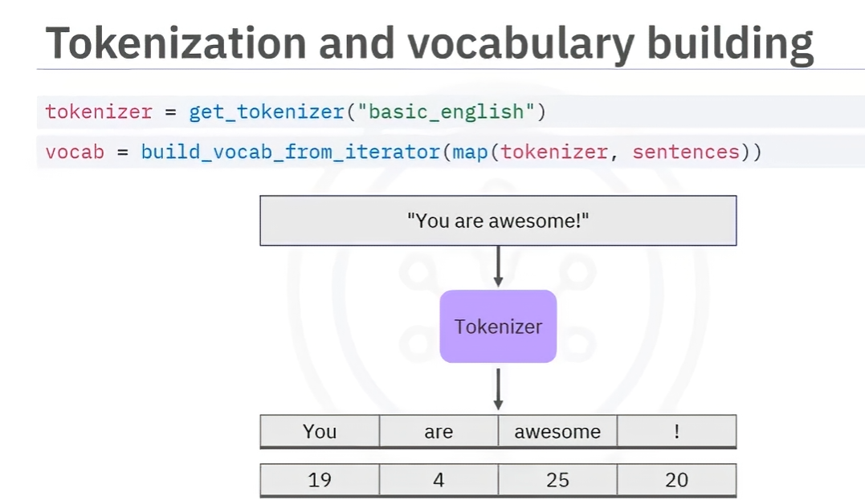

* + **Numericalization**: Maps tokens to numbers using a vocabulary.
  + **Padding**: Ensures all sequences in a batch have the same length using pad_sequence().

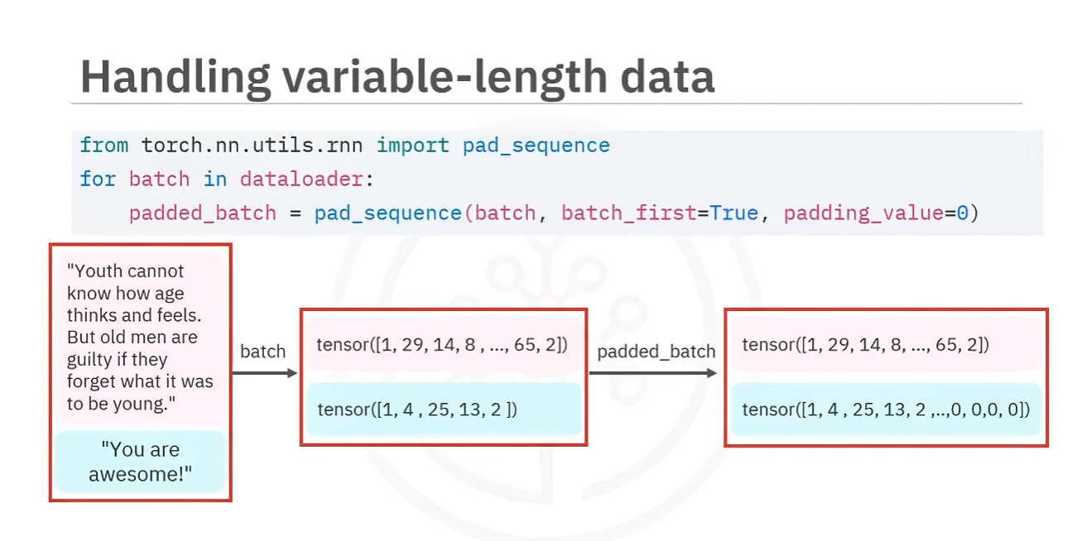

* + **Batch Dimension Control**:
    - batch_first=True: First dimension is the batch size.

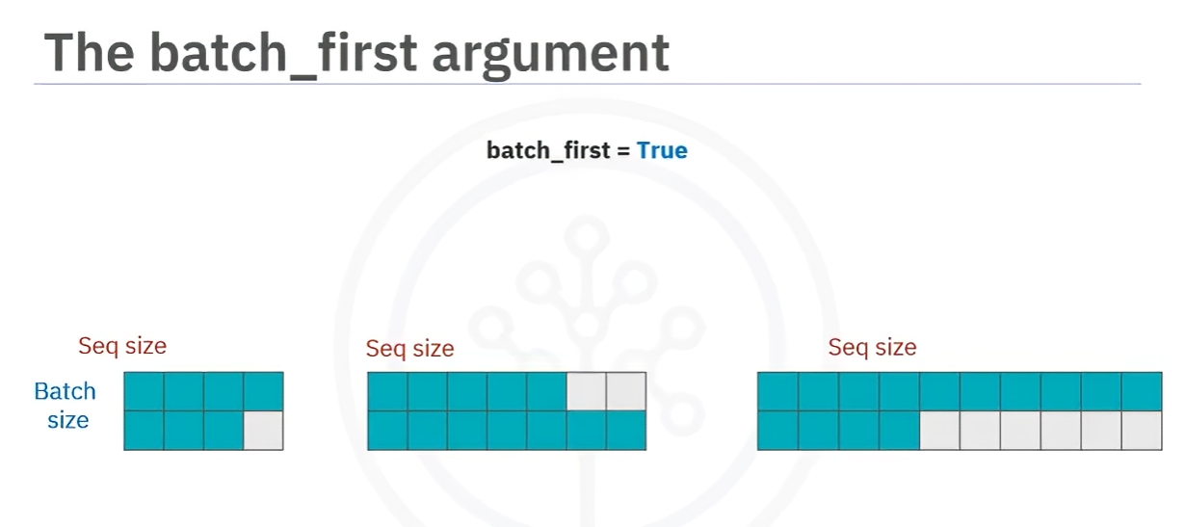

* + - batch_first=False: First dimension is sequence length.

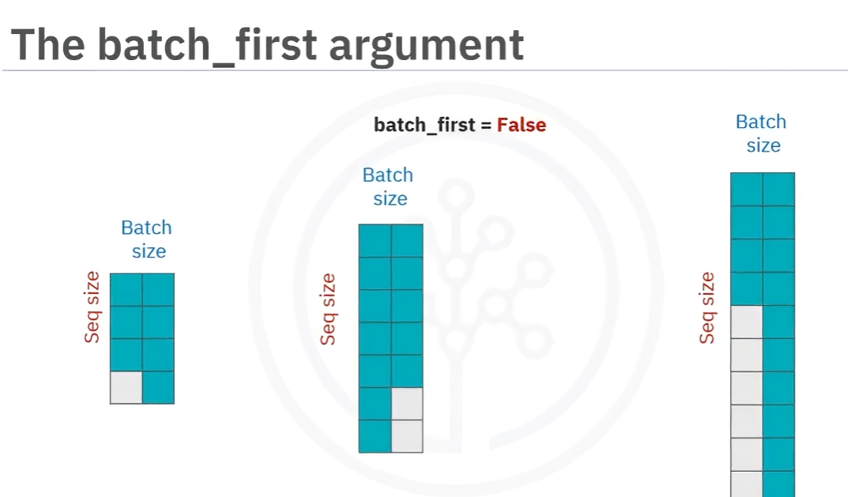

* Examples for batchfirst

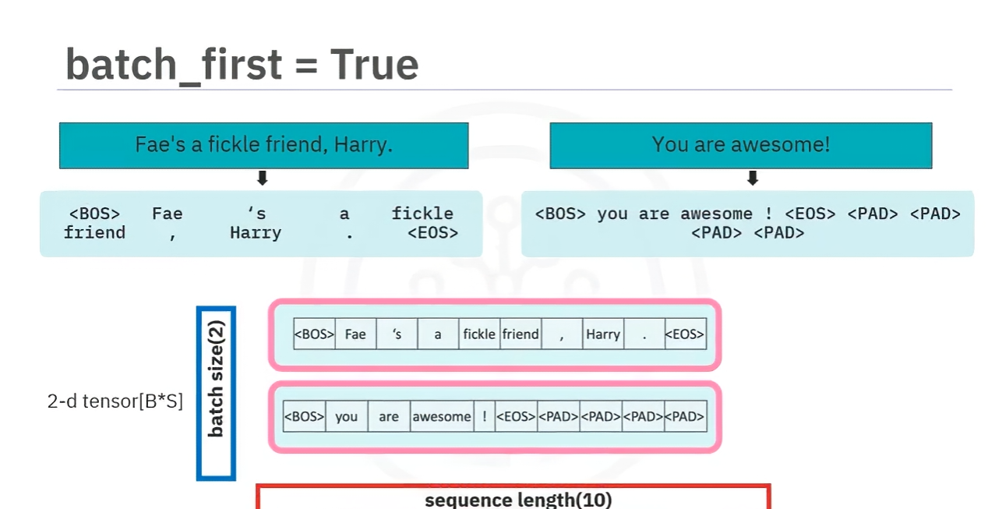

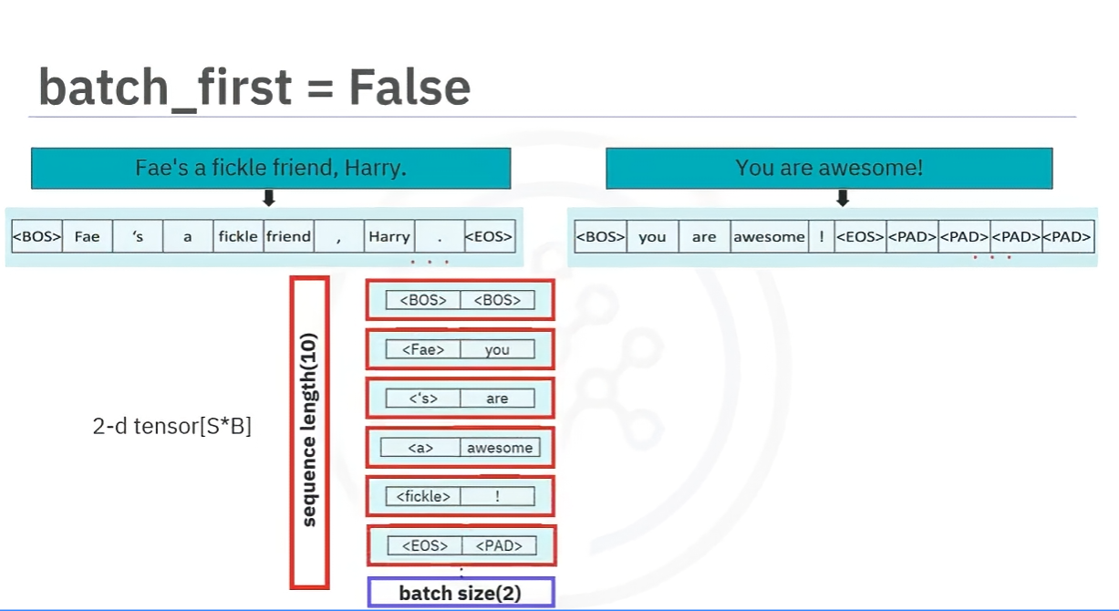

1. **Collate Function for Custom Processing**
   * The **collate function** handles batch transformations such as tokenization, indexing, and tensor conversion.
   * Example process:
     + Tokenize each sample.
     + Convert tokens to numerical indices.
     + Apply padding for uniform sequence length.

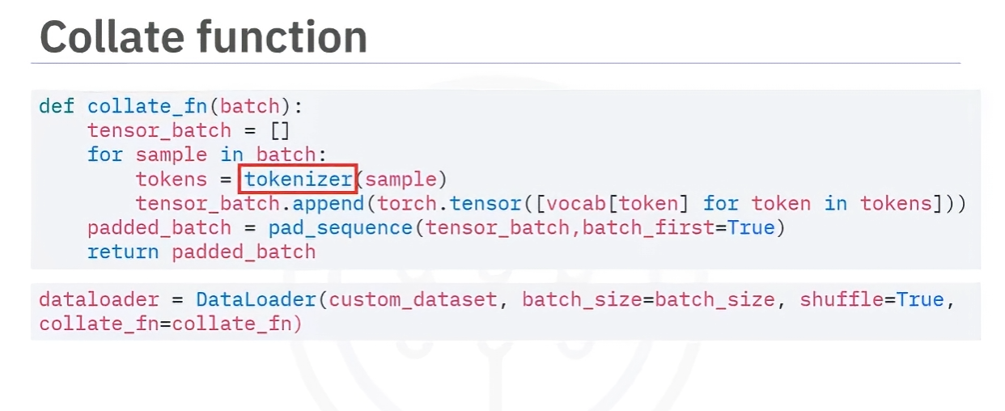

1. **Key Takeaways**
   * **Data loaders** optimize memory usage and improve training efficiency.
   * Enable **batch processing, shuffling, and transformations** in PyTorch.
   * **Collate functions** help preprocess data dynamically during batch loading.
   * **Batch-first setting** determines whether batch size or sequence length is the primary dimension.

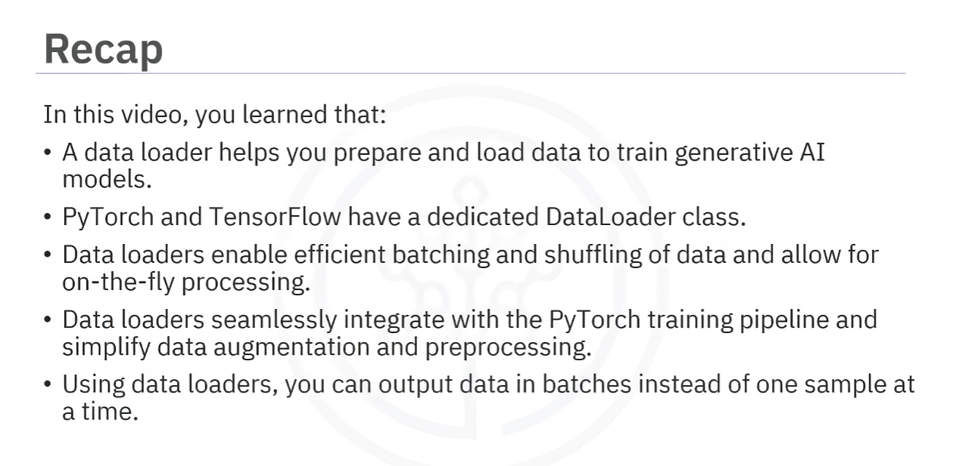

## Data Quality and Diversity for Effective LLM Training

High-quality and diverse data are crucial for training robust and inclusive large language models (LLMs). Key considerations include:

* **Data Quality**: Ensure accuracy, consistency, and completeness by removing noise, verifying consistency, and improving labeling quality.
* **Diverse Representation**: Incorporate various demographics, balance data sources, and include regional and linguistic diversity to prevent biases.
* **Regular Updates**: Continuously update datasets to reflect evolving vocabulary, cultural norms, and societal changes.
* **Ethical Considerations**: Protect user privacy, ensure fair representation, and maintain transparency in data sources.

By focusing on these factors, LLMs can become more accurate, inclusive, and socially responsible, improving AI fairness and representation.